1 run......

Downloading: 100%

464/464 [00:00<00:00, 12.4kB/s]

Downloading: 100%

270M/270M [00:09<00:00, 27.7MB/s]

training 1 epoch...

31.953479766845703 seconds used......

1 training finished! average train loss: 0.4198841254826616

evaluating...

Confusion matrix, without normalization

[[ 0 0 41]

[ 0 0 95]

[ 0 0 714]]

Normalized confusion matrix

[[0. 0. 1.]

[0. 0. 1.]

[0. 0. 1.]]

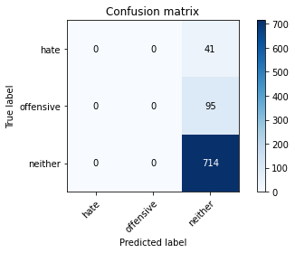

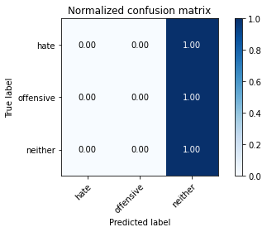

/opt/conda/lib/python3.7/site-packages/sklearn/metrics/_classification.py:1245: UndefinedMetricWarning: Precision and F-score are ill-defined and being set to 0.0 in labels with no predicted samples. Use `zero_division` parameter to control this behavior.

_warn_prf(average, modifier, msg_start, len(result))

/opt/conda/lib/python3.7/site-packages/sklearn/metrics/_classification.py:1245: UndefinedMetricWarning: Precision and F-score are ill-defined and being set to 0.0 in labels with no predicted samples. Use `zero_division` parameter to control this behavior.

_warn_prf(average, modifier, msg_start, len(result))

/opt/conda/lib/python3.7/site-packages/sklearn/metrics/_classification.py:1245: UndefinedMetricWarning: Precision and F-score are ill-defined and being set to 0.0 in labels with no predicted samples. Use `zero_division` parameter to control this behavior.

_warn_prf(average, modifier, msg_start, len(result))

precision recall f1-score support

hate 0.00 0.00 0.00 41

offensive 0.00 0.00 0.00 95

neither 0.84 1.00 0.91 714

accuracy 0.84 850

macro avg 0.28 0.33 0.30 850

weighted avg 0.71 0.84 0.77 850

average eval_loss: 0.5425925973456266, accuracy: 0.84

training 2 epoch...

31.06748914718628 seconds used......

2 training finished! average train loss: 0.3241358424844074

evaluating...

Confusion matrix, without normalization

[[ 0 0 41]

[ 0 0 95]

[ 0 1 713]]

Normalized confusion matrix

[[0. 0. 1. ]

[0. 0. 1. ]

[0. 0.00140056 0.99859944]]

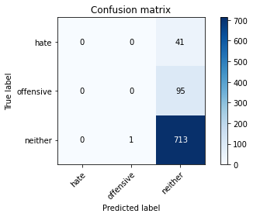



/opt/conda/lib/python3.7/site-packages/sklearn/metrics/_classification.py:1245: UndefinedMetricWarning: Precision and F-score are ill-defined and being set to 0.0 in labels with no predicted samples. Use `zero_division` parameter to control this behavior.

_warn_prf(average, modifier, msg_start, len(result))

/opt/conda/lib/python3.7/site-packages/sklearn/metrics/_classification.py:1245: UndefinedMetricWarning: Precision and F-score are ill-defined and being set to 0.0 in labels with no predicted samples. Use `zero_division` parameter to control this behavior.

_warn_prf(average, modifier, msg_start, len(result))

/opt/conda/lib/python3.7/site-packages/sklearn/metrics/_classification.py:1245: UndefinedMetricWarning: Precision and F-score are ill-defined and being set to 0.0 in labels with no predicted samples. Use `zero_division` parameter to control this behavior.

_warn_prf(average, modifier, msg_start, len(result))

precision recall f1-score support

hate 0.00 0.00 0.00 41

offensive 0.00 0.00 0.00 95

neither 0.84 1.00 0.91 714

accuracy 0.84 850

macro avg 0.28 0.33 0.30 850

weighted avg 0.71 0.84 0.77 850

average eval_loss: 0.5279154209528378, accuracy: 0.8388235294117647

training 3 epoch...

31.140312910079956 seconds used......

3 training finished! average train loss: 0.22985537835830794

evaluating...

Confusion matrix, without normalization

[[ 1 3 37]

[ 1 14 80]

[ 2 31 681]]

Normalized confusion matrix

[[0.02439024 0.07317073 0.90243902]

[0.01052632 0.14736842 0.84210526]

[0.00280112 0.04341737 0.95378151]]

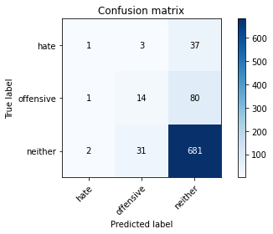

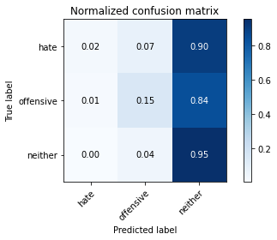

precision recall f1-score support

hate 0.25 0.02 0.04 41

offensive 0.29 0.15 0.20 95

neither 0.85 0.95 0.90 714

accuracy 0.82 850

macro avg 0.47 0.38 0.38 850

weighted avg 0.76 0.82 0.78 850

average eval_loss: 0.49223129378718344, accuracy: 0.8188235294117647

training 4 epoch...

31.040979385375977 seconds used......

4 training finished! average train loss: 0.10291941044730236

evaluating...

Confusion matrix, without normalization

[[ 0 1 40]

[ 0 5 90]

[ 2 22 690]]

Normalized confusion matrix

[[0. 0.02439024 0.97560976]

[0. 0.05263158 0.94736842]

[0.00280112 0.03081232 0.96638655]]

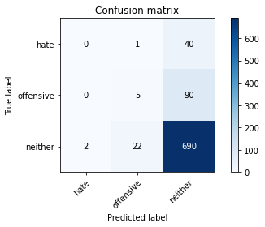

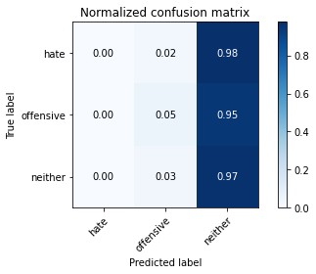

precision recall f1-score support

hate 0.00 0.00 0.00 41

offensive 0.18 0.05 0.08 95

neither 0.84 0.97 0.90 714

accuracy 0.82 850

macro avg 0.34 0.34 0.33 850

weighted avg 0.73 0.82 0.76 850

average eval_loss: 0.8286740052416314, accuracy: 0.8176470588235294

training 5 epoch...

31.051533937454224 seconds used......

5 training finished! average train loss: 0.03496600034298054

evaluating...

Confusion matrix, without normalization

[[ 0 1 40]

[ 2 2 91]

[ 4 3 707]]

Normalized confusion matrix

[[0. 0.02439024 0.97560976]

[0.02105263 0.02105263 0.95789474]

[0.00560224 0.00420168 0.99019608]]

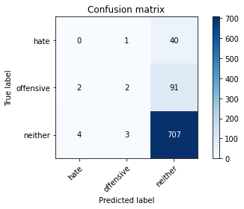

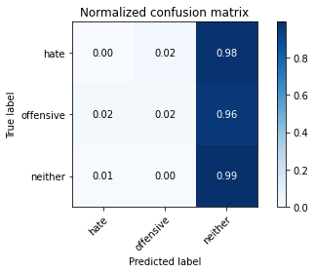

precision recall f1-score support

hate 0.00 0.00 0.00 41

offensive 0.33 0.02 0.04 95

neither 0.84 0.99 0.91 714

accuracy 0.83 850

macro avg 0.39 0.34 0.32 850

weighted avg 0.75 0.83 0.77 850

average eval_loss: 1.0757816043035344, accuracy: 0.8341176470588235

training 6 epoch...

31.11665940284729 seconds used......

6 training finished! average train loss: 0.011680867098892322

evaluating...

Confusion matrix, without normalization

[[ 0 1 40]

[ 4 6 85]

[ 10 6 698]]

Normalized confusion matrix

[[0. 0.02439024 0.97560976]

[0.04210526 0.06315789 0.89473684]

[0.0140056 0.00840336 0.97759104]]

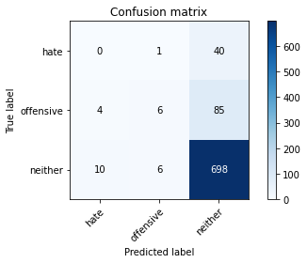

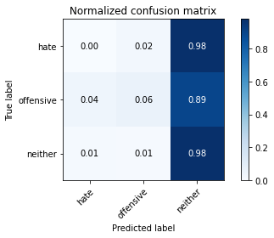

precision recall f1-score support

hate 0.00 0.00 0.00 41

offensive 0.46 0.06 0.11 95

neither 0.85 0.98 0.91 714

accuracy 0.83 850

macro avg 0.44 0.35 0.34 850

weighted avg 0.76 0.83 0.78 850

average eval_loss: 1.1222418210606921, accuracy: 0.8282352941176471

training 7 epoch...

31.089598178863525 seconds used......

7 training finished! average train loss: 0.004041457015573637

evaluating...

Confusion matrix, without normalization

[[ 0 1 40]

[ 2 6 87]

[ 4 11 699]]

Normalized confusion matrix

[[0. 0.02439024 0.97560976]

[0.02105263 0.06315789 0.91578947]

[0.00560224 0.01540616 0.9789916 ]]

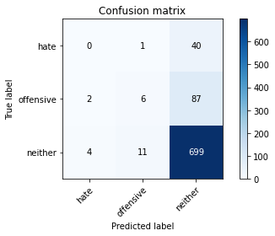

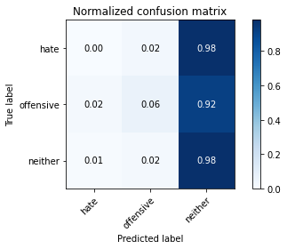

precision recall f1-score support

hate 0.00 0.00 0.00 41

offensive 0.33 0.06 0.11 95

neither 0.85 0.98 0.91 714

accuracy 0.83 850

macro avg 0.39 0.35 0.34 850

weighted avg 0.75 0.83 0.77 850

average eval_loss: 1.2376192677434437, accuracy: 0.8294117647058824

training 8 epoch...

31.092362880706787 seconds used......

8 training finished! average train loss: 0.0036510678255581297

evaluating...

Confusion matrix, without normalization

[[ 0 6 35]

[ 0 33 62]

[ 0 47 667]]

Normalized confusion matrix

[[0. 0.14634146 0.85365854]

[0. 0.34736842 0.65263158]

[0. 0.06582633 0.93417367]]

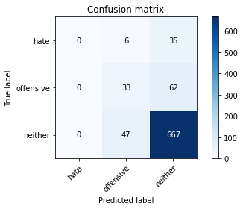

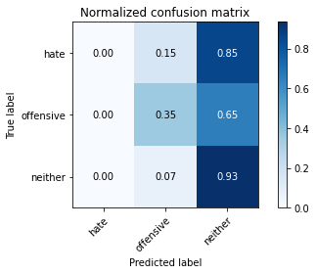

/opt/conda/lib/python3.7/site-packages/sklearn/metrics/_classification.py:1245: UndefinedMetricWarning: Precision and F-score are ill-defined and being set to 0.0 in labels with no predicted samples. Use `zero_division` parameter to control this behavior.

_warn_prf(average, modifier, msg_start, len(result))

/opt/conda/lib/python3.7/site-packages/sklearn/metrics/_classification.py:1245: UndefinedMetricWarning: Precision and F-score are ill-defined and being set to 0.0 in labels with no predicted samples. Use `zero_division` parameter to control this behavior.

_warn_prf(average, modifier, msg_start, len(result))

/opt/conda/lib/python3.7/site-packages/sklearn/metrics/_classification.py:1245: UndefinedMetricWarning: Precision and F-score are ill-defined and being set to 0.0 in labels with no predicted samples. Use `zero_division` parameter to control this behavior.

_warn_prf(average, modifier, msg_start, len(result))

precision recall f1-score support

hate 0.00 0.00 0.00 41

offensive 0.38 0.35 0.36 95

neither 0.87 0.93 0.90 714

accuracy 0.82 850

macro avg 0.42 0.43 0.42 850

weighted avg 0.78 0.82 0.80 850

average eval_loss: 1.1140989618440873, accuracy: 0.8235294117647058

training 9 epoch...

31.14054250717163 seconds used......

9 training finished! average train loss: 0.003539239021171438

evaluating...

Confusion matrix, without normalization

[[ 0 2 39]

[ 2 7 86]

[ 9 24 681]]

Normalized confusion matrix

[[0. 0.04878049 0.95121951]

[0.02105263 0.07368421 0.90526316]

[0.01260504 0.03361345 0.95378151]]

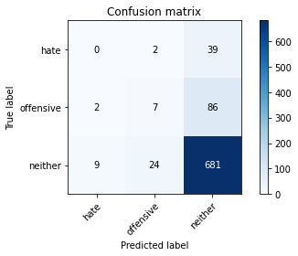

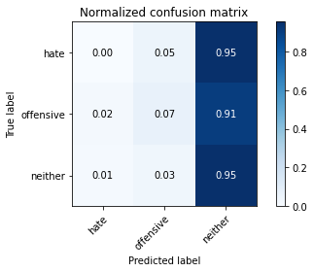

precision recall f1-score support

hate 0.00 0.00 0.00 41

offensive 0.21 0.07 0.11 95

neither 0.84 0.95 0.90 714

accuracy 0.81 850

macro avg 0.35 0.34 0.34 850

weighted avg 0.73 0.81 0.76 850

average eval_loss: 1.3443671888803799, accuracy: 0.8094117647058824

training 10 epoch...

31.15464448928833 seconds used......

10 training finished! average train loss: 0.016591058816467913

evaluating...

Confusion matrix, without normalization

[[ 0 0 41]

[ 0 1 94]

[ 0 4 710]]

Normalized confusion matrix

[[0. 0. 1. ]

[0. 0.01052632 0.98947368]

[0. 0.00560224 0.99439776]]

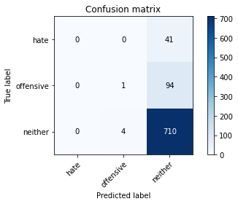

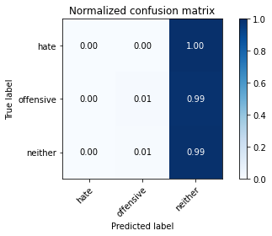

/opt/conda/lib/python3.7/site-packages/sklearn/metrics/_classification.py:1245: UndefinedMetricWarning: Precision and F-score are ill-defined and being set to 0.0 in labels with no predicted samples. Use `zero_division` parameter to control this behavior.

_warn_prf(average, modifier, msg_start, len(result))

/opt/conda/lib/python3.7/site-packages/sklearn/metrics/_classification.py:1245: UndefinedMetricWarning: Precision and F-score are ill-defined and being set to 0.0 in labels with no predicted samples. Use `zero_division` parameter to control this behavior.

_warn_prf(average, modifier, msg_start, len(result))

/opt/conda/lib/python3.7/site-packages/sklearn/metrics/_classification.py:1245: UndefinedMetricWarning: Precision and F-score are ill-defined and being set to 0.0 in labels with no predicted samples. Use `zero_division` parameter to control this behavior.

_warn_prf(average, modifier, msg_start, len(result))

precision recall f1-score support

hate 0.00 0.00 0.00 41

offensive 0.20 0.01 0.02 95

neither 0.84 0.99 0.91 714

accuracy 0.84 850

macro avg 0.35 0.33 0.31 850

weighted avg 0.73 0.84 0.77 850

average eval_loss: 1.5421435797211733, accuracy: 0.8364705882352941

2 run......

training 1 epoch...

31.17607593536377 seconds used......

1 training finished! average train loss: 0.41284145797110355

evaluating...

Confusion matrix, without normalization

[[ 0 0 41]

[ 0 0 95]

[ 0 0 714]]

Normalized confusion matrix

[[0. 0. 1.]

[0. 0. 1.]

[0. 0. 1.]]





/opt/conda/lib/python3.7/site-packages/sklearn/metrics/_classification.py:1245: UndefinedMetricWarning: Precision and F-score are ill-defined and being set to 0.0 in labels with no predicted samples. Use `zero_division` parameter to control this behavior.

_warn_prf(average, modifier, msg_start, len(result))

/opt/conda/lib/python3.7/site-packages/sklearn/metrics/_classification.py:1245: UndefinedMetricWarning: Precision and F-score are ill-defined and being set to 0.0 in labels with no predicted samples. Use `zero_division` parameter to control this behavior.

_warn_prf(average, modifier, msg_start, len(result))

/opt/conda/lib/python3.7/site-packages/sklearn/metrics/_classification.py:1245: UndefinedMetricWarning: Precision and F-score are ill-defined and being set to 0.0 in labels with no predicted samples. Use `zero_division` parameter to control this behavior.

_warn_prf(average, modifier, msg_start, len(result))

precision recall f1-score support

hate 0.00 0.00 0.00 41

offensive 0.00 0.00 0.00 95

neither 0.84 1.00 0.91 714

accuracy 0.84 850

macro avg 0.28 0.33 0.30 850

weighted avg 0.71 0.84 0.77 850

average eval_loss: 0.5186265333187442, accuracy: 0.84

training 2 epoch...

31.140639543533325 seconds used......

2 training finished! average train loss: 0.3141996408983363

evaluating...

Confusion matrix, without normalization

[[ 0 1 40]

[ 0 6 89]

[ 0 19 695]]

Normalized confusion matrix

[[0. 0.02439024 0.97560976]

[0. 0.06315789 0.93684211]

[0. 0.02661064 0.97338936]]

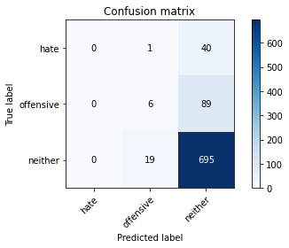

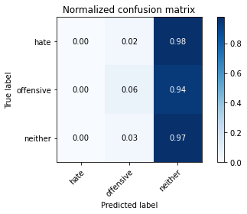

/opt/conda/lib/python3.7/site-packages/sklearn/metrics/_classification.py:1245: UndefinedMetricWarning: Precision and F-score are ill-defined and being set to 0.0 in labels with no predicted samples. Use `zero_division` parameter to control this behavior.

_warn_prf(average, modifier, msg_start, len(result))

/opt/conda/lib/python3.7/site-packages/sklearn/metrics/_classification.py:1245: UndefinedMetricWarning: Precision and F-score are ill-defined and being set to 0.0 in labels with no predicted samples. Use `zero_division` parameter to control this behavior.

_warn_prf(average, modifier, msg_start, len(result))

/opt/conda/lib/python3.7/site-packages/sklearn/metrics/_classification.py:1245: UndefinedMetricWarning: Precision and F-score are ill-defined and being set to 0.0 in labels with no predicted samples. Use `zero_division` parameter to control this behavior.

_warn_prf(average, modifier, msg_start, len(result))

precision recall f1-score support

hate 0.00 0.00 0.00 41

offensive 0.23 0.06 0.10 95

neither 0.84 0.97 0.90 714

accuracy 0.82 850

macro avg 0.36 0.35 0.33 850

weighted avg 0.73 0.82 0.77 850

average eval_loss: 0.4705615961317753, accuracy: 0.8247058823529412

training 3 epoch...

31.143118619918823 seconds used......

3 training finished! average train loss: 0.1957207312417358

evaluating...

Confusion matrix, without normalization

[[ 0 2 39]

[ 1 4 90]

[ 1 9 704]]

Normalized confusion matrix

[[0. 0.04878049 0.95121951]

[0.01052632 0.04210526 0.94736842]

[0.00140056 0.01260504 0.9859944 ]]

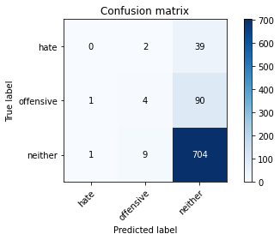

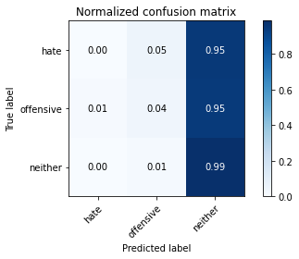

precision recall f1-score support

hate 0.00 0.00 0.00 41

offensive 0.27 0.04 0.07 95

neither 0.85 0.99 0.91 714

accuracy 0.83 850

macro avg 0.37 0.34 0.33 850

weighted avg 0.74 0.83 0.77 850

average eval_loss: 0.6244481161269251, accuracy: 0.8329411764705882

training 4 epoch...

31.13919687271118 seconds used......

4 training finished! average train loss: 0.07008894142897126

evaluating...

Confusion matrix, without normalization

[[ 3 4 34]

[ 3 13 79]

[ 19 30 665]]

Normalized confusion matrix

[[0.07317073 0.09756098 0.82926829]

[0.03157895 0.13684211 0.83157895]

[0.02661064 0.04201681 0.93137255]]

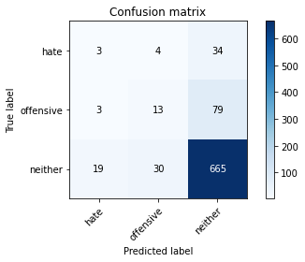

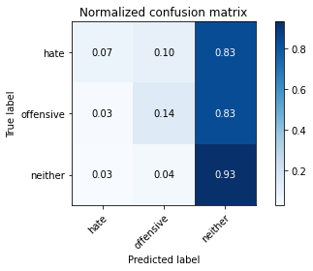

precision recall f1-score support

hate 0.12 0.07 0.09 41

offensive 0.28 0.14 0.18 95

neither 0.85 0.93 0.89 714

accuracy 0.80 850

macro avg 0.42 0.38 0.39 850

weighted avg 0.75 0.80 0.77 850

average eval_loss: 0.8431826684607713, accuracy: 0.8011764705882353

training 5 epoch...

30.949302673339844 seconds used......

5 training finished! average train loss: 0.03270054575731168

evaluating...

Confusion matrix, without normalization

[[ 1 0 40]

[ 3 6 86]

[ 11 14 689]]

Normalized confusion matrix

[[0.02439024 0. 0.97560976]

[0.03157895 0.06315789 0.90526316]

[0.01540616 0.01960784 0.96498599]]

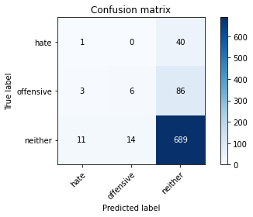

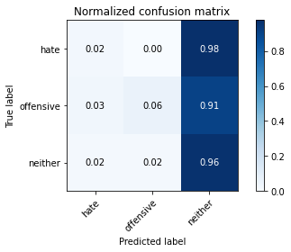

precision recall f1-score support

hate 0.07 0.02 0.04 41

offensive 0.30 0.06 0.10 95

neither 0.85 0.96 0.90 714

accuracy 0.82 850

macro avg 0.40 0.35 0.35 850

weighted avg 0.75 0.82 0.77 850

average eval_loss: 1.0953837150875696, accuracy: 0.8188235294117647

training 6 epoch...

31.036316633224487 seconds used......

6 training finished! average train loss: 0.019341077458074424

evaluating...

Confusion matrix, without normalization

[[ 1 0 40]

[ 1 8 86]

[ 8 18 688]]

Normalized confusion matrix

[[0.02439024 0. 0.97560976]

[0.01052632 0.08421053 0.90526316]

[0.01120448 0.02521008 0.96358543]]

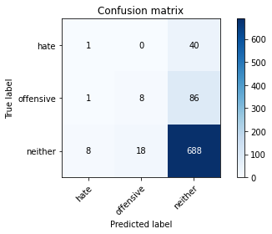

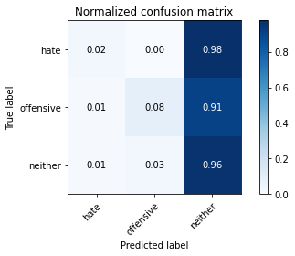

precision recall f1-score support

hate 0.10 0.02 0.04 41

offensive 0.31 0.08 0.13 95

neither 0.85 0.96 0.90 714

accuracy 0.82 850

macro avg 0.42 0.36 0.36 850

weighted avg 0.75 0.82 0.77 850

average eval_loss: 1.1473082922639997, accuracy: 0.82

training 7 epoch...

31.0163893699646 seconds used......

7 training finished! average train loss: 0.004909984670525797

evaluating...

Confusion matrix, without normalization

[[ 0 1 40]

[ 1 11 83]

[ 8 25 681]]

Normalized confusion matrix

[[0. 0.02439024 0.97560976]

[0.01052632 0.11578947 0.87368421]

[0.01120448 0.03501401 0.95378151]]

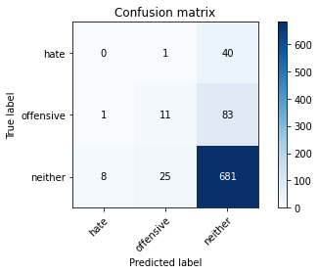

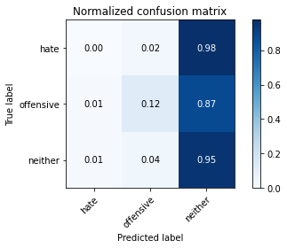

precision recall f1-score support

hate 0.00 0.00 0.00 41

offensive 0.30 0.12 0.17 95

neither 0.85 0.95 0.90 714

accuracy 0.81 850

macro avg 0.38 0.36 0.35 850

weighted avg 0.74 0.81 0.77 850

average eval_loss: 1.201788875671492, accuracy: 0.8141176470588235

training 8 epoch...

31.079305410385132 seconds used......

8 training finished! average train loss: 0.0038911570025076457

evaluating...

Confusion matrix, without normalization

[[ 1 1 39]

[ 1 6 88]

[ 6 16 692]]

Normalized confusion matrix

[[0.02439024 0.02439024 0.95121951]

[0.01052632 0.06315789 0.92631579]

[0.00840336 0.02240896 0.96918768]]

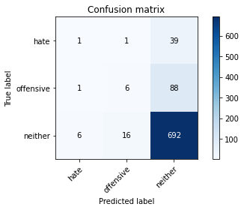

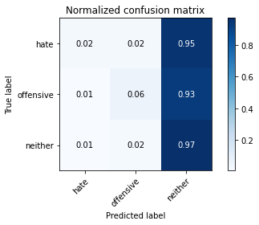

precision recall f1-score support

hate 0.12 0.02 0.04 41

offensive 0.26 0.06 0.10 95

neither 0.84 0.97 0.90 714

accuracy 0.82 850

macro avg 0.41 0.35 0.35 850

weighted avg 0.74 0.82 0.77 850

average eval_loss: 1.3589480460556609, accuracy: 0.8223529411764706

training 9 epoch...

31.01064658164978 seconds used......

9 training finished! average train loss: 0.000983128762765573

evaluating...

Confusion matrix, without normalization

[[ 1 1 39]

[ 1 6 88]

[ 6 16 692]]

Normalized confusion matrix

[[0.02439024 0.02439024 0.95121951]

[0.01052632 0.06315789 0.92631579]

[0.00840336 0.02240896 0.96918768]]





precision recall f1-score support

hate 0.12 0.02 0.04 41

offensive 0.26 0.06 0.10 95

neither 0.84 0.97 0.90 714

accuracy 0.82 850

macro avg 0.41 0.35 0.35 850

weighted avg 0.74 0.82 0.77 850

average eval_loss: 1.4277744619754484, accuracy: 0.8223529411764706

training 10 epoch...

31.02591824531555 seconds used......

10 training finished! average train loss: 0.003437536612125016

evaluating...

Confusion matrix, without normalization

[[ 1 0 40]

[ 0 3 92]

[ 1 13 700]]

Normalized confusion matrix

[[0.02439024 0. 0.97560976]

[0. 0.03157895 0.96842105]

[0.00140056 0.01820728 0.98039216]]

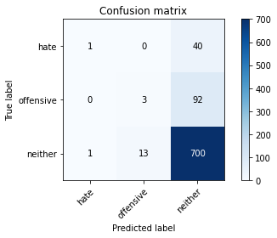

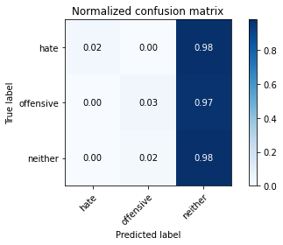

precision recall f1-score support

hate 0.50 0.02 0.05 41

offensive 0.19 0.03 0.05 95

neither 0.84 0.98 0.91 714

accuracy 0.83 850

macro avg 0.51 0.35 0.34 850

weighted avg 0.75 0.83 0.77 850

average eval_loss: 1.4787829456618902, accuracy: 0.8282352941176471

3 run......

training 1 epoch...

31.007912397384644 seconds used......

1 training finished! average train loss: 0.4165055739903013

evaluating...

Confusion matrix, without normalization

[[ 0 0 41]

[ 0 0 95]

[ 0 0 714]]

Normalized confusion matrix

[[0. 0. 1.]

[0. 0. 1.]

[0. 0. 1.]]





/opt/conda/lib/python3.7/site-packages/sklearn/metrics/_classification.py:1245: UndefinedMetricWarning: Precision and F-score are ill-defined and being set to 0.0 in labels with no predicted samples. Use `zero_division` parameter to control this behavior.

_warn_prf(average, modifier, msg_start, len(result))

/opt/conda/lib/python3.7/site-packages/sklearn/metrics/_classification.py:1245: UndefinedMetricWarning: Precision and F-score are ill-defined and being set to 0.0 in labels with no predicted samples. Use `zero_division` parameter to control this behavior.

_warn_prf(average, modifier, msg_start, len(result))

/opt/conda/lib/python3.7/site-packages/sklearn/metrics/_classification.py:1245: UndefinedMetricWarning: Precision and F-score are ill-defined and being set to 0.0 in labels with no predicted samples. Use `zero_division` parameter to control this behavior.

_warn_prf(average, modifier, msg_start, len(result))

precision recall f1-score support

hate 0.00 0.00 0.00 41

offensive 0.00 0.00 0.00 95

neither 0.84 1.00 0.91 714

accuracy 0.84 850

macro avg 0.28 0.33 0.30 850

weighted avg 0.71 0.84 0.77 850

average eval_loss: 0.5221685584807811, accuracy: 0.84

training 2 epoch...

31.03604292869568 seconds used......

2 training finished! average train loss: 0.31421964981286

evaluating...

Confusion matrix, without normalization

[[ 0 0 41]

[ 0 0 95]

[ 0 1 713]]

Normalized confusion matrix

[[0. 0. 1. ]

[0. 0. 1. ]

[0. 0.00140056 0.99859944]]





/opt/conda/lib/python3.7/site-packages/sklearn/metrics/_classification.py:1245: UndefinedMetricWarning: Precision and F-score are ill-defined and being set to 0.0 in labels with no predicted samples. Use `zero_division` parameter to control this behavior.

_warn_prf(average, modifier, msg_start, len(result))

/opt/conda/lib/python3.7/site-packages/sklearn/metrics/_classification.py:1245: UndefinedMetricWarning: Precision and F-score are ill-defined and being set to 0.0 in labels with no predicted samples. Use `zero_division` parameter to control this behavior.

_warn_prf(average, modifier, msg_start, len(result))

/opt/conda/lib/python3.7/site-packages/sklearn/metrics/_classification.py:1245: UndefinedMetricWarning: Precision and F-score are ill-defined and being set to 0.0 in labels with no predicted samples. Use `zero_division` parameter to control this behavior.

_warn_prf(average, modifier, msg_start, len(result))

precision recall f1-score support

hate 0.00 0.00 0.00 41

offensive 0.00 0.00 0.00 95

neither 0.84 1.00 0.91 714

accuracy 0.84 850

macro avg 0.28 0.33 0.30 850

weighted avg 0.71 0.84 0.77 850

average eval_loss: 0.6296064636431807, accuracy: 0.8388235294117647

training 3 epoch...

31.086451292037964 seconds used......

3 training finished! average train loss: 0.19966971140881484

evaluating...

Confusion matrix, without normalization

[[ 1 13 27]

[ 3 11 81]

[ 6 59 649]]

Normalized confusion matrix

[[0.02439024 0.31707317 0.65853659]

[0.03157895 0.11578947 0.85263158]

[0.00840336 0.08263305 0.90896359]]

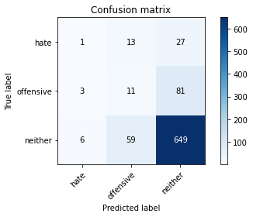

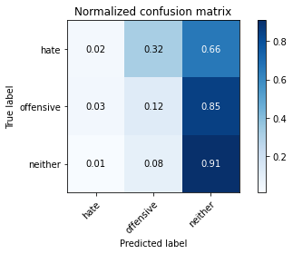

precision recall f1-score support

hate 0.10 0.02 0.04 41

offensive 0.13 0.12 0.12 95

neither 0.86 0.91 0.88 714

accuracy 0.78 850

macro avg 0.36 0.35 0.35 850

weighted avg 0.74 0.78 0.76 850

average eval_loss: 0.6071158663023176, accuracy: 0.7776470588235294

training 4 epoch...

31.013334274291992 seconds used......

4 training finished! average train loss: 0.08315455378764626

evaluating...

Confusion matrix, without normalization

[[ 3 4 34]

[ 3 16 76]

[ 11 23 680]]

Normalized confusion matrix

[[0.07317073 0.09756098 0.82926829]

[0.03157895 0.16842105 0.8 ]

[0.01540616 0.03221289 0.95238095]]

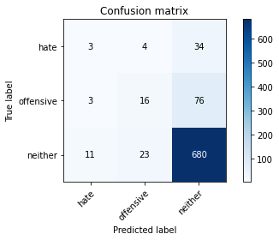

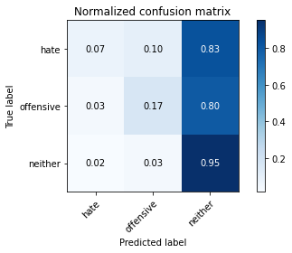

precision recall f1-score support

hate 0.18 0.07 0.10 41

offensive 0.37 0.17 0.23 95

neither 0.86 0.95 0.90 714

accuracy 0.82 850

macro avg 0.47 0.40 0.41 850

weighted avg 0.77 0.82 0.79 850

average eval_loss: 0.7214683175796296, accuracy: 0.8223529411764706

training 5 epoch...

31.019153594970703 seconds used......

5 training finished! average train loss: 0.03948772269366943

evaluating...

Confusion matrix, without normalization

[[ 5 3 33]

[ 3 13 79]

[ 24 16 674]]

Normalized confusion matrix

[[0.12195122 0.07317073 0.80487805]

[0.03157895 0.13684211 0.83157895]

[0.03361345 0.02240896 0.94397759]]

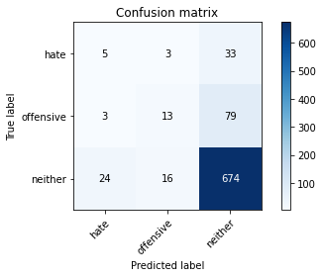

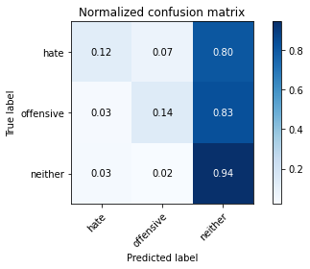

precision recall f1-score support

hate 0.16 0.12 0.14 41

offensive 0.41 0.14 0.20 95

neither 0.86 0.94 0.90 714

accuracy 0.81 850

macro avg 0.47 0.40 0.41 850

weighted avg 0.77 0.81 0.78 850

average eval_loss: 0.9174594827711062, accuracy: 0.8141176470588235

training 6 epoch...

31.023868322372437 seconds used......

6 training finished! average train loss: 0.01633200016334721

evaluating...

Confusion matrix, without normalization

[[ 0 2 39]

[ 2 10 83]

[ 5 18 691]]

Normalized confusion matrix

[[0. 0.04878049 0.95121951]

[0.02105263 0.10526316 0.87368421]

[0.0070028 0.02521008 0.96778711]]

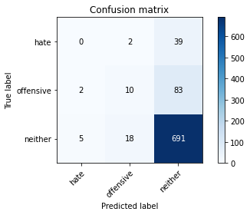

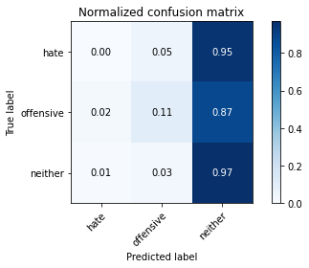

precision recall f1-score support

hate 0.00 0.00 0.00 41

offensive 0.33 0.11 0.16 95

neither 0.85 0.97 0.91 714

accuracy 0.82 850

macro avg 0.39 0.36 0.36 850

weighted avg 0.75 0.82 0.78 850

average eval_loss: 1.0642932416752067, accuracy: 0.8247058823529412

training 7 epoch...

30.995837926864624 seconds used......

7 training finished! average train loss: 0.014874249118007232

evaluating...

Confusion matrix, without normalization

[[ 0 2 39]

[ 3 10 82]

[ 11 15 688]]

Normalized confusion matrix

[[0. 0.04878049 0.95121951]

[0.03157895 0.10526316 0.86315789]

[0.01540616 0.0210084 0.96358543]]

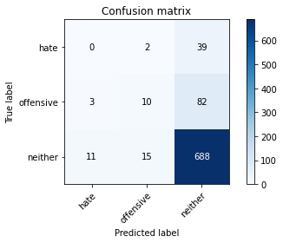

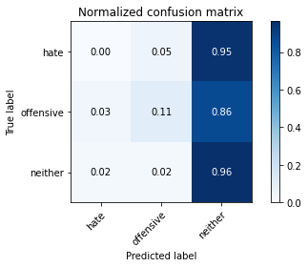

precision recall f1-score support

hate 0.00 0.00 0.00 41

offensive 0.37 0.11 0.16 95

neither 0.85 0.96 0.90 714

accuracy 0.82 850

macro avg 0.41 0.36 0.36 850

weighted avg 0.76 0.82 0.78 850

average eval_loss: 1.0475910862076616, accuracy: 0.8211764705882353

training 8 epoch...

31.123255729675293 seconds used......

8 training finished! average train loss: 0.004763945678726853

evaluating...

Confusion matrix, without normalization

[[ 0 2 39]

[ 2 2 91]

[ 5 7 702]]

Normalized confusion matrix

[[0. 0.04878049 0.95121951]

[0.02105263 0.02105263 0.95789474]

[0.0070028 0.00980392 0.98319328]]

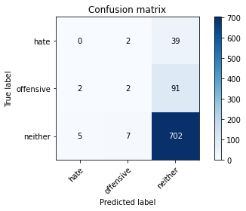

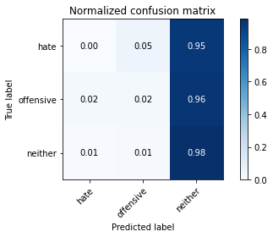

precision recall f1-score support

hate 0.00 0.00 0.00 41

offensive 0.18 0.02 0.04 95

neither 0.84 0.98 0.91 714

accuracy 0.83 850

macro avg 0.34 0.33 0.32 850

weighted avg 0.73 0.83 0.77 850

average eval_loss: 1.2903021083180901, accuracy: 0.8282352941176471

training 9 epoch...

31.130093812942505 seconds used......

9 training finished! average train loss: 0.0009481564285453039

evaluating...

Confusion matrix, without normalization

[[ 0 2 39]

[ 2 7 86]

[ 4 13 697]]

Normalized confusion matrix

[[0. 0.04878049 0.95121951]

[0.02105263 0.07368421 0.90526316]

[0.00560224 0.01820728 0.97619048]]

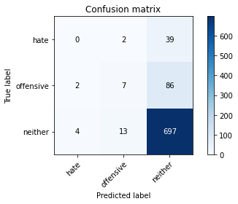

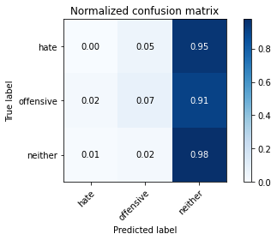

precision recall f1-score support

hate 0.00 0.00 0.00 41

offensive 0.32 0.07 0.12 95

neither 0.85 0.98 0.91 714

accuracy 0.83 850

macro avg 0.39 0.35 0.34 850

weighted avg 0.75 0.83 0.78 850

average eval_loss: 1.302953730099415, accuracy: 0.8282352941176471

training 10 epoch...

31.08301281929016 seconds used......

10 training finished! average train loss: 0.0008469331971155138

evaluating...

Confusion matrix, without normalization

[[ 0 3 38]

[ 2 13 80]

[ 11 19 684]]

Normalized confusion matrix

[[0. 0.07317073 0.92682927]

[0.02105263 0.13684211 0.84210526]

[0.01540616 0.02661064 0.95798319]]

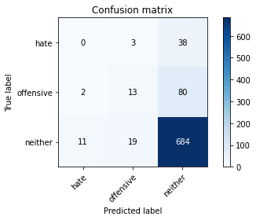

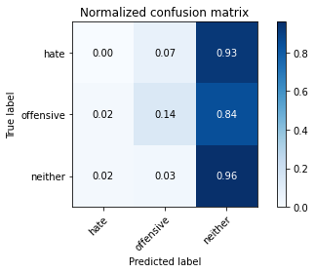

precision recall f1-score support

hate 0.00 0.00 0.00 41

offensive 0.37 0.14 0.20 95

neither 0.85 0.96 0.90 714

accuracy 0.82 850

macro avg 0.41 0.36 0.37 850

weighted avg 0.76 0.82 0.78 850

average eval_loss: 1.241428982341076, accuracy: 0.82

4 run......

training 1 epoch...

31.141661405563354 seconds used......

1 training finished! average train loss: 0.42033671911474296

evaluating...

Confusion matrix, without normalization

[[ 0 0 41]

[ 0 0 95]

[ 0 0 714]]

Normalized confusion matrix

[[0. 0. 1.]

[0. 0. 1.]

[0. 0. 1.]]





/opt/conda/lib/python3.7/site-packages/sklearn/metrics/_classification.py:1245: UndefinedMetricWarning: Precision and F-score are ill-defined and being set to 0.0 in labels with no predicted samples. Use `zero_division` parameter to control this behavior.

_warn_prf(average, modifier, msg_start, len(result))

/opt/conda/lib/python3.7/site-packages/sklearn/metrics/_classification.py:1245: UndefinedMetricWarning: Precision and F-score are ill-defined and being set to 0.0 in labels with no predicted samples. Use `zero_division` parameter to control this behavior.

_warn_prf(average, modifier, msg_start, len(result))

/opt/conda/lib/python3.7/site-packages/sklearn/metrics/_classification.py:1245: UndefinedMetricWarning: Precision and F-score are ill-defined and being set to 0.0 in labels with no predicted samples. Use `zero_division` parameter to control this behavior.

_warn_prf(average, modifier, msg_start, len(result))

precision recall f1-score support

hate 0.00 0.00 0.00 41

offensive 0.00 0.00 0.00 95

neither 0.84 1.00 0.91 714

accuracy 0.84 850

macro avg 0.28 0.33 0.30 850

weighted avg 0.71 0.84 0.77 850

average eval_loss: 0.5003461088378762, accuracy: 0.84

training 2 epoch...

31.03883194923401 seconds used......

2 training finished! average train loss: 0.33166369682675256

evaluating...

Confusion matrix, without normalization

[[ 0 0 41]

[ 0 0 95]

[ 0 0 714]]

Normalized confusion matrix

[[0. 0. 1.]

[0. 0. 1.]

[0. 0. 1.]]





/opt/conda/lib/python3.7/site-packages/sklearn/metrics/_classification.py:1245: UndefinedMetricWarning: Precision and F-score are ill-defined and being set to 0.0 in labels with no predicted samples. Use `zero_division` parameter to control this behavior.

_warn_prf(average, modifier, msg_start, len(result))

/opt/conda/lib/python3.7/site-packages/sklearn/metrics/_classification.py:1245: UndefinedMetricWarning: Precision and F-score are ill-defined and being set to 0.0 in labels with no predicted samples. Use `zero_division` parameter to control this behavior.

_warn_prf(average, modifier, msg_start, len(result))

/opt/conda/lib/python3.7/site-packages/sklearn/metrics/_classification.py:1245: UndefinedMetricWarning: Precision and F-score are ill-defined and being set to 0.0 in labels with no predicted samples. Use `zero_division` parameter to control this behavior.

_warn_prf(average, modifier, msg_start, len(result))

precision recall f1-score support

hate 0.00 0.00 0.00 41

offensive 0.00 0.00 0.00 95

neither 0.84 1.00 0.91 714

accuracy 0.84 850

macro avg 0.28 0.33 0.30 850

weighted avg 0.71 0.84 0.77 850

average eval_loss: 0.5972874363841012, accuracy: 0.84

training 3 epoch...

31.10695743560791 seconds used......

3 training finished! average train loss: 0.21762686194510672

evaluating...

Confusion matrix, without normalization

[[ 1 2 38]

[ 1 3 91]

[ 0 20 694]]

Normalized confusion matrix

[[0.02439024 0.04878049 0.92682927]

[0.01052632 0.03157895 0.95789474]

[0. 0.0280112 0.9719888 ]]

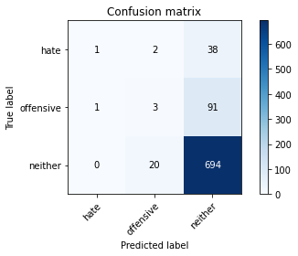

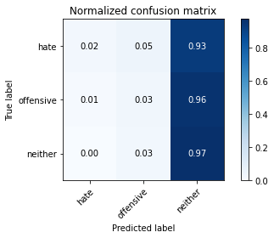

precision recall f1-score support

hate 0.50 0.02 0.05 41

offensive 0.12 0.03 0.05 95

neither 0.84 0.97 0.90 714

accuracy 0.82 850

macro avg 0.49 0.34 0.33 850

weighted avg 0.75 0.82 0.77 850

average eval_loss: 0.566239827799849, accuracy: 0.8211764705882353

training 4 epoch...

31.031304359436035 seconds used......

4 training finished! average train loss: 0.10160318441159964

evaluating...

Confusion matrix, without normalization

[[ 0 1 40]

[ 1 2 92]

[ 0 4 710]]

Normalized confusion matrix

[[0. 0.02439024 0.97560976]

[0.01052632 0.02105263 0.96842105]

[0. 0.00560224 0.99439776]]

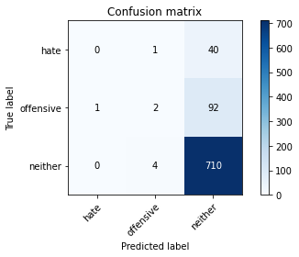

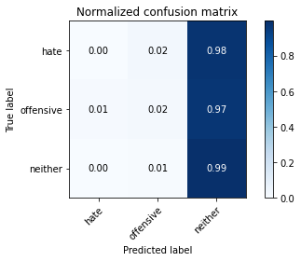

precision recall f1-score support

hate 0.00 0.00 0.00 41

offensive 0.29 0.02 0.04 95

neither 0.84 0.99 0.91 714

accuracy 0.84 850

macro avg 0.38 0.34 0.32 850

weighted avg 0.74 0.84 0.77 850

average eval_loss: 0.8966157705236096, accuracy: 0.8376470588235294

training 5 epoch...

31.150537252426147 seconds used......

5 training finished! average train loss: 0.04264450794224827

evaluating...

Confusion matrix, without normalization

[[ 1 1 39]

[ 3 3 89]

[ 11 9 694]]

Normalized confusion matrix

[[0.02439024 0.02439024 0.95121951]

[0.03157895 0.03157895 0.93684211]

[0.01540616 0.01260504 0.9719888 ]]

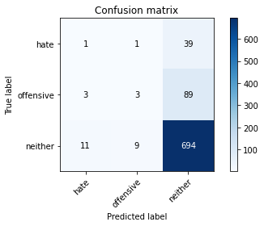

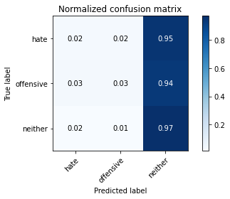

precision recall f1-score support

hate 0.07 0.02 0.04 41

offensive 0.23 0.03 0.06 95

neither 0.84 0.97 0.90 714

accuracy 0.82 850

macro avg 0.38 0.34 0.33 850

weighted avg 0.74 0.82 0.77 850

average eval_loss: 1.0094123391385819, accuracy: 0.8211764705882353

training 6 epoch...

31.102797985076904 seconds used......

6 training finished! average train loss: 0.018755902932086444

evaluating...

Confusion matrix, without normalization

[[ 3 8 30]

[ 2 27 66]

[ 10 32 672]]

Normalized confusion matrix

[[0.07317073 0.19512195 0.73170732]

[0.02105263 0.28421053 0.69473684]

[0.0140056 0.04481793 0.94117647]]

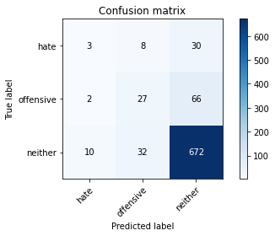

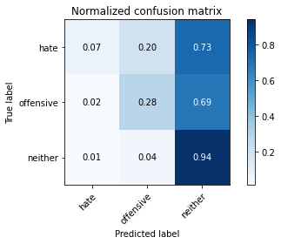

precision recall f1-score support

hate 0.20 0.07 0.11 41

offensive 0.40 0.28 0.33 95

neither 0.88 0.94 0.91 714

accuracy 0.83 850

macro avg 0.49 0.43 0.45 850

weighted avg 0.79 0.83 0.80 850

average eval_loss: 0.7953291576867382, accuracy: 0.8258823529411765

training 7 epoch...

31.05822491645813 seconds used......

7 training finished! average train loss: 0.005326784068367478

evaluating...

Confusion matrix, without normalization

[[ 0 1 40]

[ 1 6 88]

[ 3 9 702]]

Normalized confusion matrix

[[0. 0.02439024 0.97560976]

[0.01052632 0.06315789 0.92631579]

[0.00420168 0.01260504 0.98319328]]

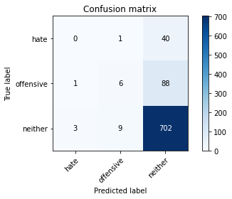

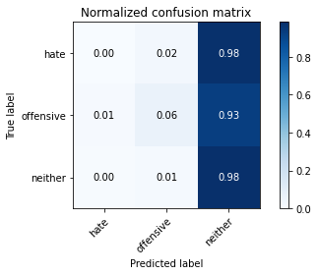

precision recall f1-score support

hate 0.00 0.00 0.00 41

offensive 0.38 0.06 0.11 95

neither 0.85 0.98 0.91 714

accuracy 0.83 850

macro avg 0.41 0.35 0.34 850

weighted avg 0.75 0.83 0.78 850

average eval_loss: 1.2073667622695887, accuracy: 0.8329411764705882

training 8 epoch...

31.096689224243164 seconds used......

8 training finished! average train loss: 0.0077748611262823935

evaluating...

Confusion matrix, without normalization

[[ 0 2 39]

[ 2 9 84]

[ 3 13 698]]

Normalized confusion matrix

[[0. 0.04878049 0.95121951]

[0.02105263 0.09473684 0.88421053]

[0.00420168 0.01820728 0.97759104]]

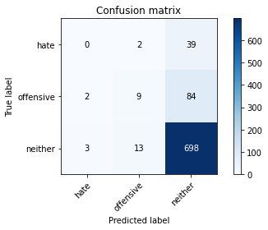

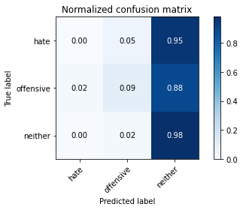

precision recall f1-score support

hate 0.00 0.00 0.00 41

offensive 0.38 0.09 0.15 95

neither 0.85 0.98 0.91 714

accuracy 0.83 850

macro avg 0.41 0.36 0.35 850

weighted avg 0.76 0.83 0.78 850

average eval_loss: 1.0662965936055624, accuracy: 0.831764705882353

training 9 epoch...

31.04710865020752 seconds used......

9 training finished! average train loss: 0.012324251047337394

evaluating...

Confusion matrix, without normalization

[[ 5 1 35]

[ 2 3 90]

[ 13 6 695]]

Normalized confusion matrix

[[0.12195122 0.02439024 0.85365854]

[0.02105263 0.03157895 0.94736842]

[0.01820728 0.00840336 0.97338936]]

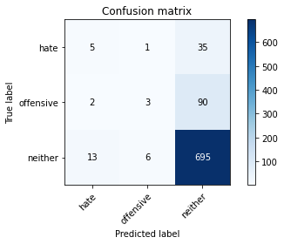

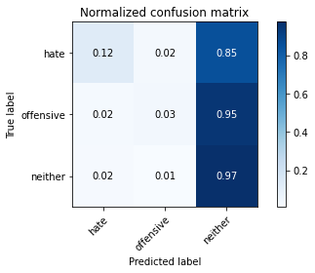

precision recall f1-score support

hate 0.25 0.12 0.16 41

offensive 0.30 0.03 0.06 95

neither 0.85 0.97 0.91 714

accuracy 0.83 850

macro avg 0.47 0.38 0.38 850

weighted avg 0.76 0.83 0.78 850

average eval_loss: 1.208966418432727, accuracy: 0.8270588235294117

training 10 epoch...

31.155964851379395 seconds used......

10 training finished! average train loss: 0.001187371120453539

evaluating...

Confusion matrix, without normalization

[[ 2 1 38]

[ 2 3 90]

[ 5 7 702]]

Normalized confusion matrix

[[0.04878049 0.02439024 0.92682927]

[0.02105263 0.03157895 0.94736842]

[0.0070028 0.00980392 0.98319328]]

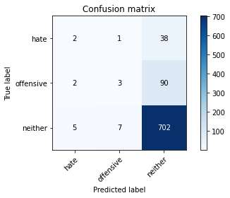

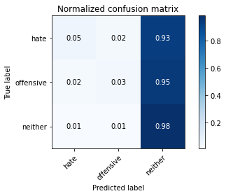

precision recall f1-score support

hate 0.22 0.05 0.08 41

offensive 0.27 0.03 0.06 95

neither 0.85 0.98 0.91 714

accuracy 0.83 850

macro avg 0.45 0.35 0.35 850

weighted avg 0.75 0.83 0.77 850

average eval_loss: 1.3012781753918823, accuracy: 0.831764705882353

5 run......

training 1 epoch...

31.03634738922119 seconds used......

1 training finished! average train loss: 0.4411524012294739

evaluating...

Confusion matrix, without normalization

[[ 0 0 41]

[ 0 0 95]

[ 0 0 714]]

Normalized confusion matrix

[[0. 0. 1.]

[0. 0. 1.]

[0. 0. 1.]]





/opt/conda/lib/python3.7/site-packages/sklearn/metrics/_classification.py:1245: UndefinedMetricWarning: Precision and F-score are ill-defined and being set to 0.0 in labels with no predicted samples. Use `zero_division` parameter to control this behavior.

_warn_prf(average, modifier, msg_start, len(result))

/opt/conda/lib/python3.7/site-packages/sklearn/metrics/_classification.py:1245: UndefinedMetricWarning: Precision and F-score are ill-defined and being set to 0.0 in labels with no predicted samples. Use `zero_division` parameter to control this behavior.

_warn_prf(average, modifier, msg_start, len(result))

/opt/conda/lib/python3.7/site-packages/sklearn/metrics/_classification.py:1245: UndefinedMetricWarning: Precision and F-score are ill-defined and being set to 0.0 in labels with no predicted samples. Use `zero_division` parameter to control this behavior.

_warn_prf(average, modifier, msg_start, len(result))

precision recall f1-score support

hate 0.00 0.00 0.00 41

offensive 0.00 0.00 0.00 95

neither 0.84 1.00 0.91 714

accuracy 0.84 850

macro avg 0.28 0.33 0.30 850

weighted avg 0.71 0.84 0.77 850

average eval_loss: 0.5130197402349738, accuracy: 0.84

training 2 epoch...

31.03785800933838 seconds used......

2 training finished! average train loss: 0.3379103453410546

evaluating...

Confusion matrix, without normalization

[[ 0 3 38]

[ 0 4 91]

[ 0 16 698]]

Normalized confusion matrix

[[0. 0.07317073 0.92682927]

[0. 0.04210526 0.95789474]

[0. 0.02240896 0.97759104]]

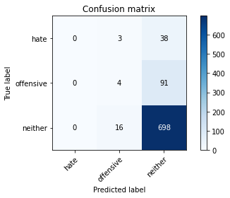

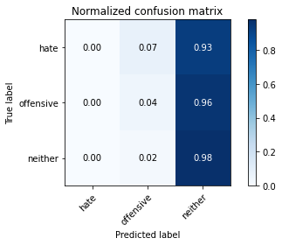

/opt/conda/lib/python3.7/site-packages/sklearn/metrics/_classification.py:1245: UndefinedMetricWarning: Precision and F-score are ill-defined and being set to 0.0 in labels with no predicted samples. Use `zero_division` parameter to control this behavior.

_warn_prf(average, modifier, msg_start, len(result))

/opt/conda/lib/python3.7/site-packages/sklearn/metrics/_classification.py:1245: UndefinedMetricWarning: Precision and F-score are ill-defined and being set to 0.0 in labels with no predicted samples. Use `zero_division` parameter to control this behavior.

_warn_prf(average, modifier, msg_start, len(result))

/opt/conda/lib/python3.7/site-packages/sklearn/metrics/_classification.py:1245: UndefinedMetricWarning: Precision and F-score are ill-defined and being set to 0.0 in labels with no predicted samples. Use `zero_division` parameter to control this behavior.

_warn_prf(average, modifier, msg_start, len(result))

precision recall f1-score support

hate 0.00 0.00 0.00 41

offensive 0.17 0.04 0.07 95

neither 0.84 0.98 0.91 714

accuracy 0.83 850

macro avg 0.34 0.34 0.32 850

weighted avg 0.73 0.83 0.77 850

average eval_loss: 0.5279817291600413, accuracy: 0.8258823529411765

training 3 epoch...

31.122226238250732 seconds used......

3 training finished! average train loss: 0.22378569049516897

evaluating...

Confusion matrix, without normalization

[[ 0 4 37]

[ 0 10 85]

[ 0 24 690]]

Normalized confusion matrix

[[0. 0.09756098 0.90243902]

[0. 0.10526316 0.89473684]

[0. 0.03361345 0.96638655]]

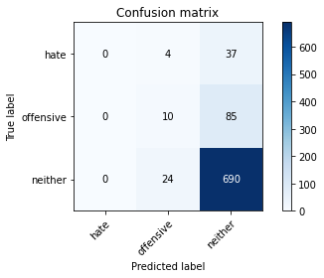

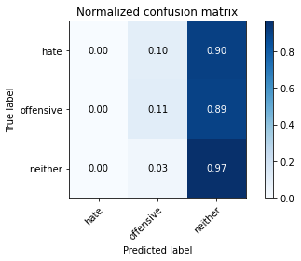

/opt/conda/lib/python3.7/site-packages/sklearn/metrics/_classification.py:1245: UndefinedMetricWarning: Precision and F-score are ill-defined and being set to 0.0 in labels with no predicted samples. Use `zero_division` parameter to control this behavior.

_warn_prf(average, modifier, msg_start, len(result))

/opt/conda/lib/python3.7/site-packages/sklearn/metrics/_classification.py:1245: UndefinedMetricWarning: Precision and F-score are ill-defined and being set to 0.0 in labels with no predicted samples. Use `zero_division` parameter to control this behavior.

_warn_prf(average, modifier, msg_start, len(result))

/opt/conda/lib/python3.7/site-packages/sklearn/metrics/_classification.py:1245: UndefinedMetricWarning: Precision and F-score are ill-defined and being set to 0.0 in labels with no predicted samples. Use `zero_division` parameter to control this behavior.

_warn_prf(average, modifier, msg_start, len(result))

precision recall f1-score support

hate 0.00 0.00 0.00 41

offensive 0.26 0.11 0.15 95

neither 0.85 0.97 0.90 714

accuracy 0.82 850

macro avg 0.37 0.36 0.35 850

weighted avg 0.74 0.82 0.78 850

average eval_loss: 0.562312129727933, accuracy: 0.8235294117647058

training 4 epoch...

31.16195321083069 seconds used......

4 training finished! average train loss: 0.10375702348952207

evaluating...

Confusion matrix, without normalization

[[ 1 4 36]

[ 4 5 86]

[ 6 22 686]]

Normalized confusion matrix

[[0.02439024 0.09756098 0.87804878]

[0.04210526 0.05263158 0.90526316]

[0.00840336 0.03081232 0.96078431]]

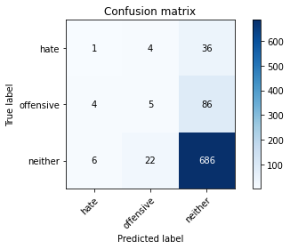

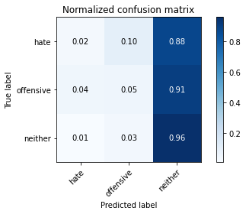

precision recall f1-score support

hate 0.09 0.02 0.04 41

offensive 0.16 0.05 0.08 95

neither 0.85 0.96 0.90 714

accuracy 0.81 850

macro avg 0.37 0.35 0.34 850

weighted avg 0.74 0.81 0.77 850

average eval_loss: 0.8062403570470769, accuracy: 0.8141176470588235

training 5 epoch...

31.059736728668213 seconds used......

5 training finished! average train loss: 0.04096525960573829

evaluating...

Confusion matrix, without normalization

[[ 4 6 31]

[ 6 14 75]

[ 18 29 667]]

Normalized confusion matrix

[[0.09756098 0.14634146 0.75609756]

[0.06315789 0.14736842 0.78947368]

[0.02521008 0.04061625 0.93417367]]

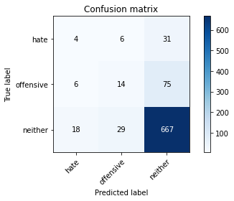

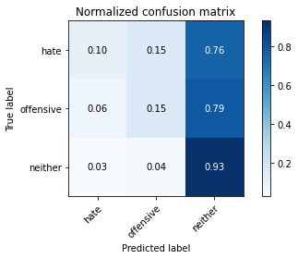

precision recall f1-score support

hate 0.14 0.10 0.12 41

offensive 0.29 0.15 0.19 95

neither 0.86 0.93 0.90 714

accuracy 0.81 850

macro avg 0.43 0.39 0.40 850

weighted avg 0.76 0.81 0.78 850

average eval_loss: 0.7472430095753394, accuracy: 0.8058823529411765

training 6 epoch...

31.04800581932068 seconds used......

6 training finished! average train loss: 0.013834426931961298

evaluating...

Confusion matrix, without normalization

[[ 2 5 34]

[ 7 14 74]

[ 18 42 654]]

Normalized confusion matrix

[[0.04878049 0.12195122 0.82926829]

[0.07368421 0.14736842 0.77894737]

[0.02521008 0.05882353 0.91596639]]

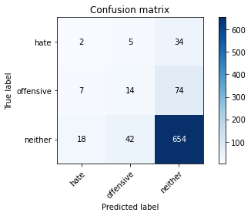

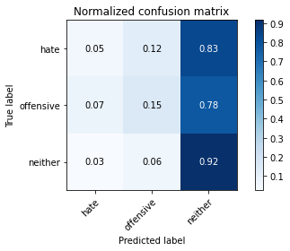

precision recall f1-score support

hate 0.07 0.05 0.06 41

offensive 0.23 0.15 0.18 95

neither 0.86 0.92 0.89 714

accuracy 0.79 850

macro avg 0.39 0.37 0.37 850

weighted avg 0.75 0.79 0.77 850

average eval_loss: 1.0505792268539702, accuracy: 0.788235294117647

training 7 epoch...

31.08246660232544 seconds used......

7 training finished! average train loss: 0.003825667423637418

evaluating...

Confusion matrix, without normalization

[[ 1 4 36]

[ 3 7 85]

[ 10 15 689]]

Normalized confusion matrix

[[0.02439024 0.09756098 0.87804878]

[0.03157895 0.07368421 0.89473684]

[0.0140056 0.0210084 0.96498599]]

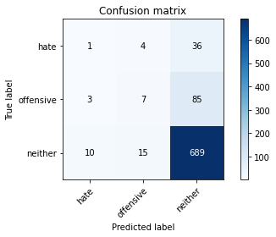

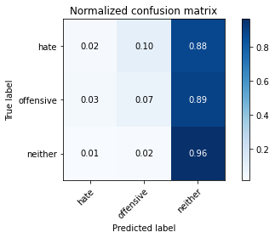

precision recall f1-score support

hate 0.07 0.02 0.04 41

offensive 0.27 0.07 0.12 95

neither 0.85 0.96 0.90 714

accuracy 0.82 850

macro avg 0.40 0.35 0.35 850

weighted avg 0.75 0.82 0.77 850

average eval_loss: 1.261836186197057, accuracy: 0.82

training 8 epoch...

31.131861925125122 seconds used......

8 training finished! average train loss: 0.014349358045165087

evaluating...

Confusion matrix, without normalization

[[ 0 3 38]

[ 4 5 86]

[ 6 13 695]]

Normalized confusion matrix

[[0. 0.07317073 0.92682927]

[0.04210526 0.05263158 0.90526316]

[0.00840336 0.01820728 0.97338936]]

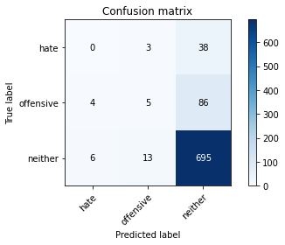

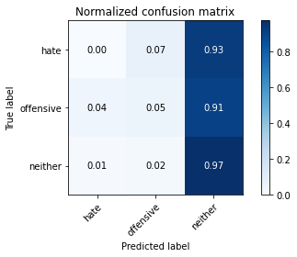

precision recall f1-score support

hate 0.00 0.00 0.00 41

offensive 0.24 0.05 0.09 95

neither 0.85 0.97 0.91 714

accuracy 0.82 850

macro avg 0.36 0.34 0.33 850

weighted avg 0.74 0.82 0.77 850

average eval_loss: 1.2509318929428552, accuracy: 0.8235294117647058

training 9 epoch...

31.05269479751587 seconds used......

9 training finished! average train loss: 0.00633867764135418

evaluating...

Confusion matrix, without normalization

[[ 2 6 33]

[ 6 14 75]

[ 12 49 653]]

Normalized confusion matrix

[[0.04878049 0.14634146 0.80487805]

[0.06315789 0.14736842 0.78947368]

[0.01680672 0.06862745 0.91456583]]

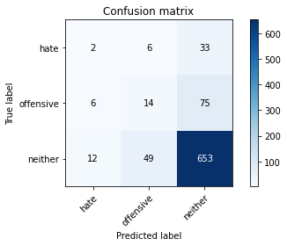

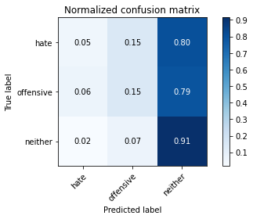

precision recall f1-score support

hate 0.10 0.05 0.07 41

offensive 0.20 0.15 0.17 95

neither 0.86 0.91 0.89 714

accuracy 0.79 850

macro avg 0.39 0.37 0.37 850

weighted avg 0.75 0.79 0.77 850

average eval_loss: 1.182151172545652, accuracy: 0.7870588235294118

training 10 epoch...

31.08653426170349 seconds used......

10 training finished! average train loss: 0.007026540404304506

evaluating...

Confusion matrix, without normalization

[[ 0 3 38]

[ 5 4 86]

[ 10 15 689]]

Normalized confusion matrix

[[0. 0.07317073 0.92682927]

[0.05263158 0.04210526 0.90526316]

[0.0140056 0.0210084 0.96498599]]

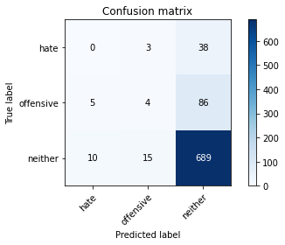

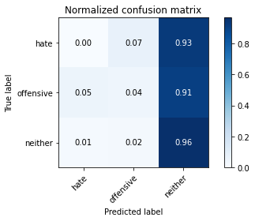

precision recall f1-score support

hate 0.00 0.00 0.00 41

offensive 0.18 0.04 0.07 95

neither 0.85 0.96 0.90 714

accuracy 0.82 850

macro avg 0.34 0.34 0.32 850

weighted avg 0.73 0.82 0.77 850

average eval_loss: 1.3598477028223663, accuracy: 0.8152941176470588